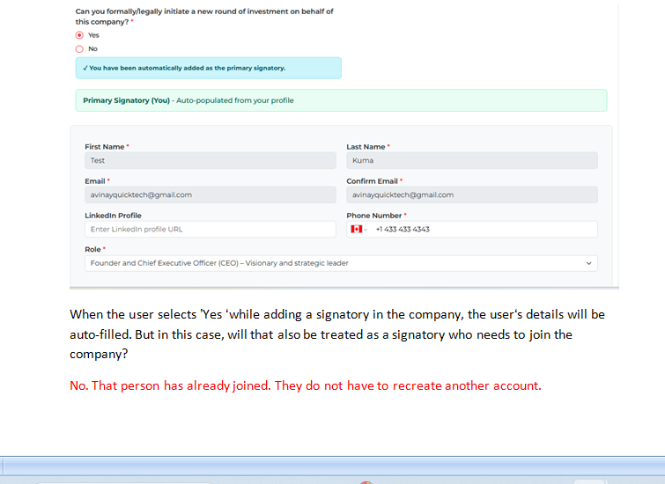
Can the same signatory be registered in multiple companies?
Yes. They can act as a signatory on several companies. For example, I am the owner of Keiretsu Forum Canada and Trendwel Ventures and BluePrint Catalyst. I can start/edit/end rounds in each of the companies. Therefore I can act as a signatory on each of the companies independently.
When a company is registered, a signatory is added, and an invitation link is sent to the signatory so they can join the company. Once the signatory creates their account, they can log in and view the company.

It’s important to make this flow clear, because earlier from your side the rule was that a signatory would only be able to view and work on the data of a single company. But in the case of “Yes or No,” when the owner’s data is being auto-filled and they are already joined, then the question arises: how will the signatory log in and view the owner’s company?

When the signatory logs in, they will have the chance to access each of the companies that they are signatories in. They can switch accounts. This is somewhat similar to investors: For example, I’m an investor (NOT AN OWNER) in Keiretsu, Trendwell and BluePrint. When I log in, I can access each of the companies independently.

The owned user’s company will be accessed from the dashboard page.,
When the owned user clicks the access button, they will be redirected to that company’s dashboard page.
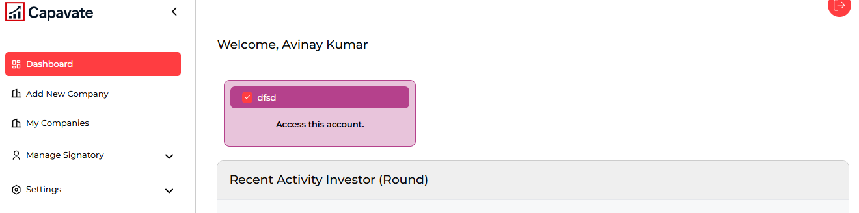

CORRECT.

